# **Web Programming**

**LOGIN GUIDE:**

**1. Employee Login:**

|  |  |
| --- | --- |
| **Username** | **Password** |
| [anjiyanathani@nu.edu.pk](mailto:anjiyanathani@nu.edu.pk) | 1234 |
| [yameenafatima@nu.edu.pk](mailto:yameenafatima@nu.edu.pk) | 1234 |

**2. Admin Login:**

|  |  |
| --- | --- |
| **Username** | **Password** |
| admin | admin |

**Project Description**

This project is an **EMPLOYEE MANAGEMENT SYSTEM** called **“FAST-EMS”**, designed to manage employee information in a work environment. An employee management system consists of crucial work-related and important personal information about an employee, such as their salary, personal information, projects and work attendance/leaves. Concisely, it is an online inventory of all employees of an organization.

Our EMS is deployed with two main users: Employees and Admin.

Employees will be registered by Admin who can manage their data, while employees are capable of viewing and editing some data.

The Admin can add new employees, assign projects to them, check project status and mark their projects, check employee Salary, and provide bonuses based on marks (automatic).

An Employee can view due Projects and Salary, submit their projects, apply for leaves and view or edit their profile information.

This is project built in HTML, CSS, JavaScript using JQuery and Bootstrap with PHP and MySQL database.

1. **Features**

|  |  |
| --- | --- |
| **Employee Panel** | **Admin Panel** |
| View Projects | Add new employees |
| View Salary | Assign Projects individually |
| View Leaderboard | Check Salary |
| View profile | Check project status |
| Update profile | Mark projects |
| Submit project | Auto Bonus |
| Apply for leave | Auto leaderboard updates |

1. **Diagrams**

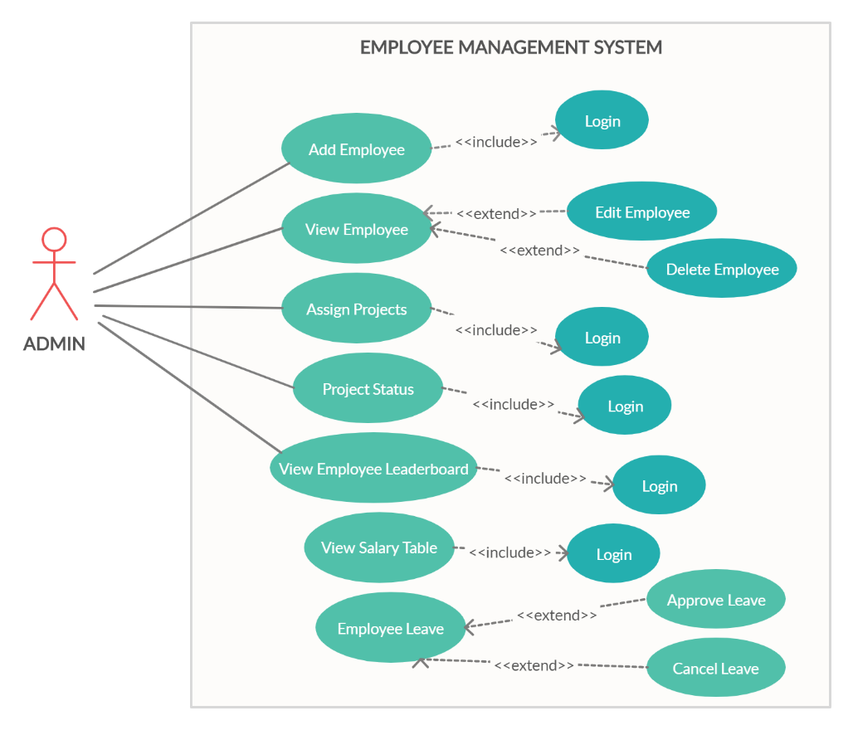

***2.1.1 Admin Use case***

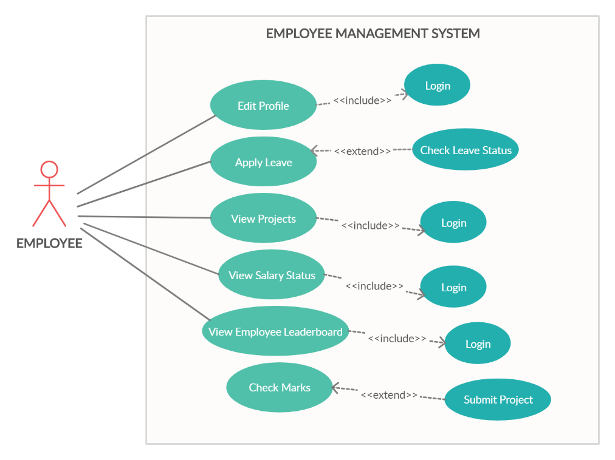

***2.1.2 Employee Use case***

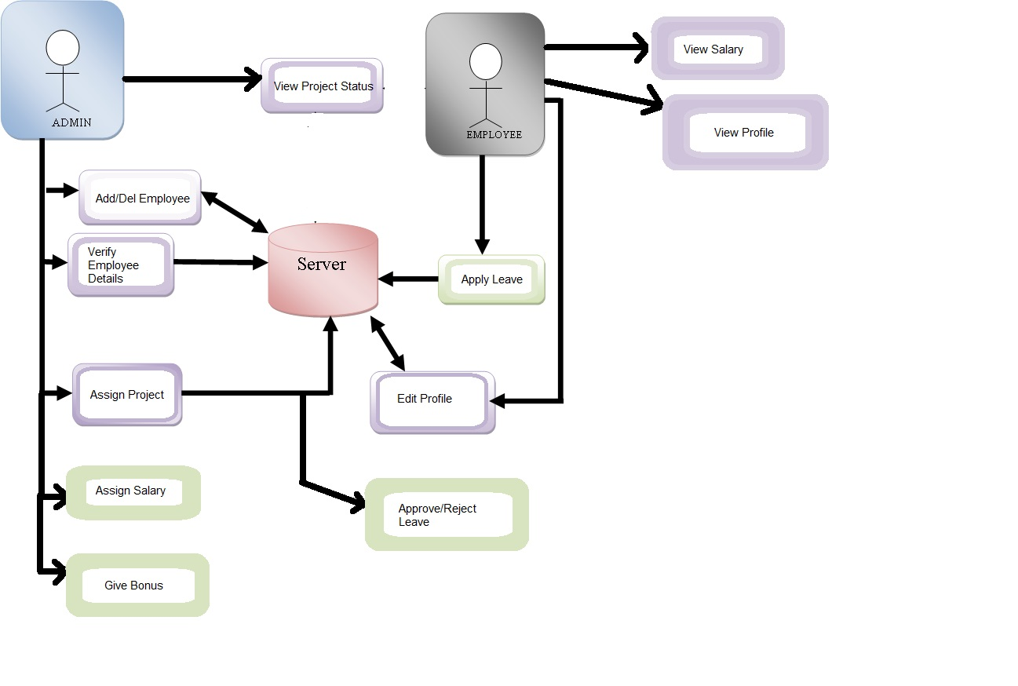

***2.2 System Architecture***

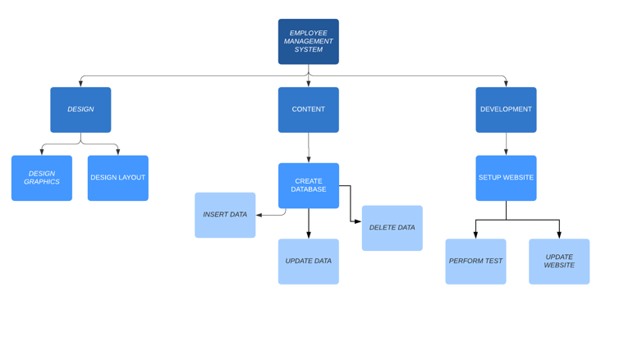

***2.3 Work Breakdown Structure***

**3. GUI**

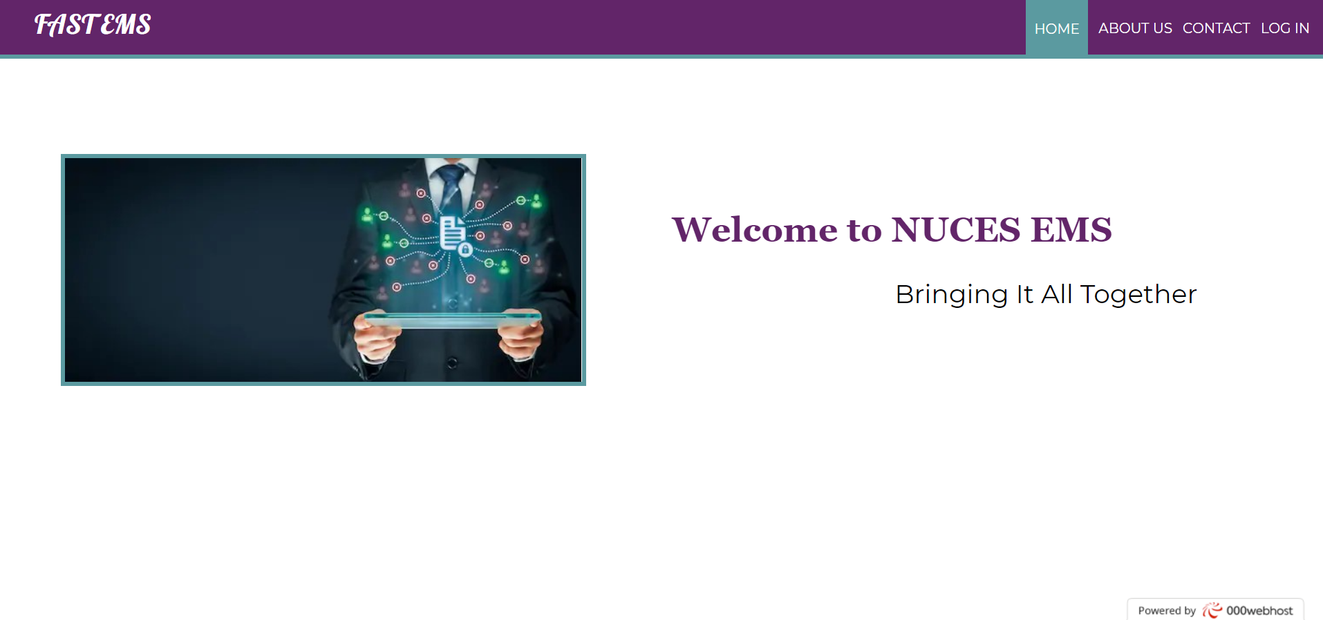

*This is the main* ***HOME*** *page of the FAST NUCES EMS. It has a non-cluttered UI with a prominent color scheme and a boldly displayed motto. The navigation bar has links to “About Us”, “Contact” and “Log in” Pages.*

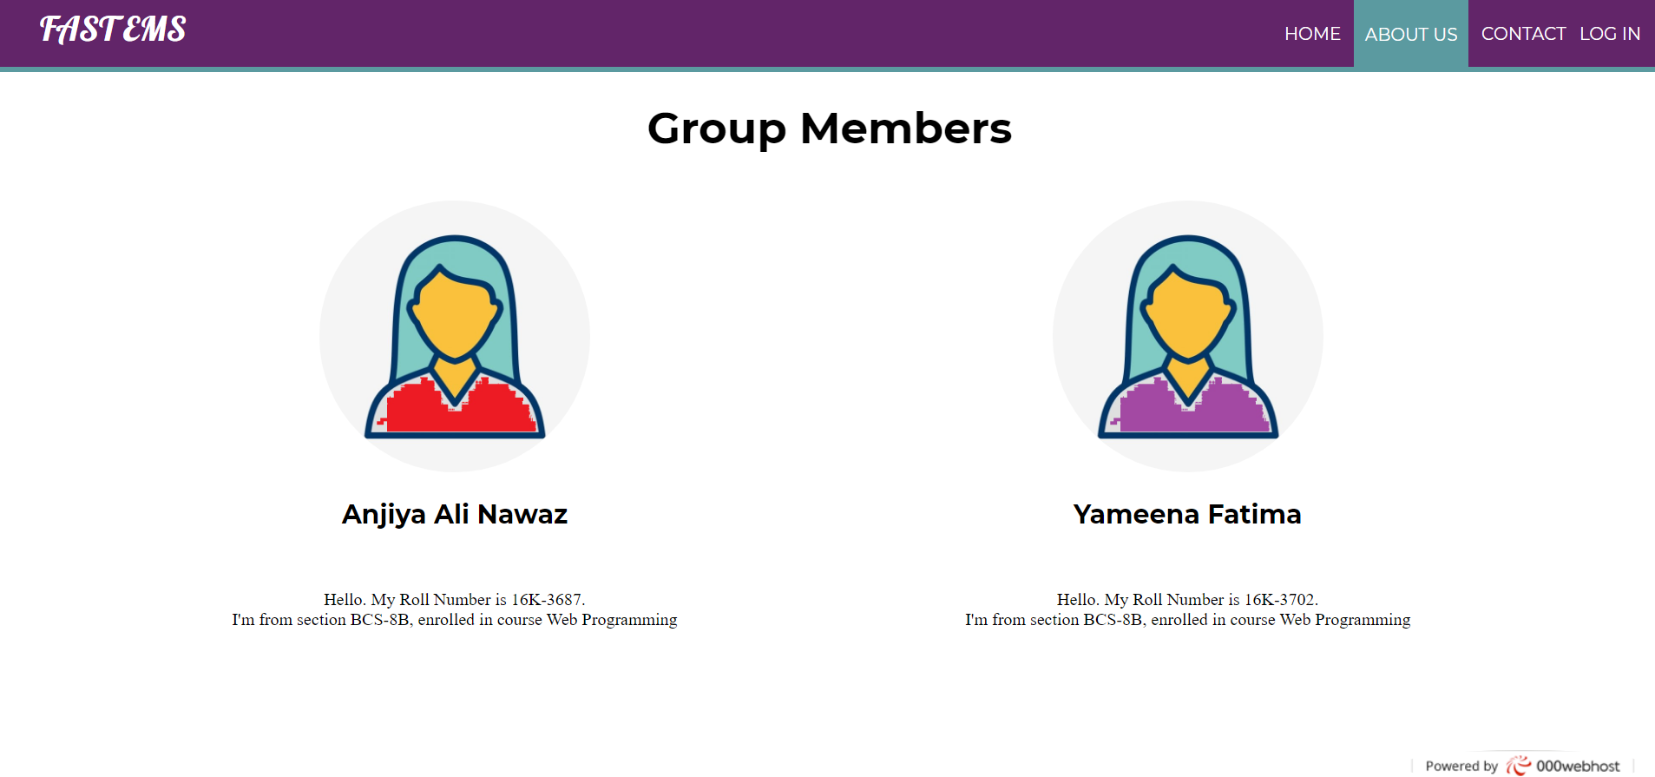

*The* ***“About us”*** *screen shows information about the two group members.*

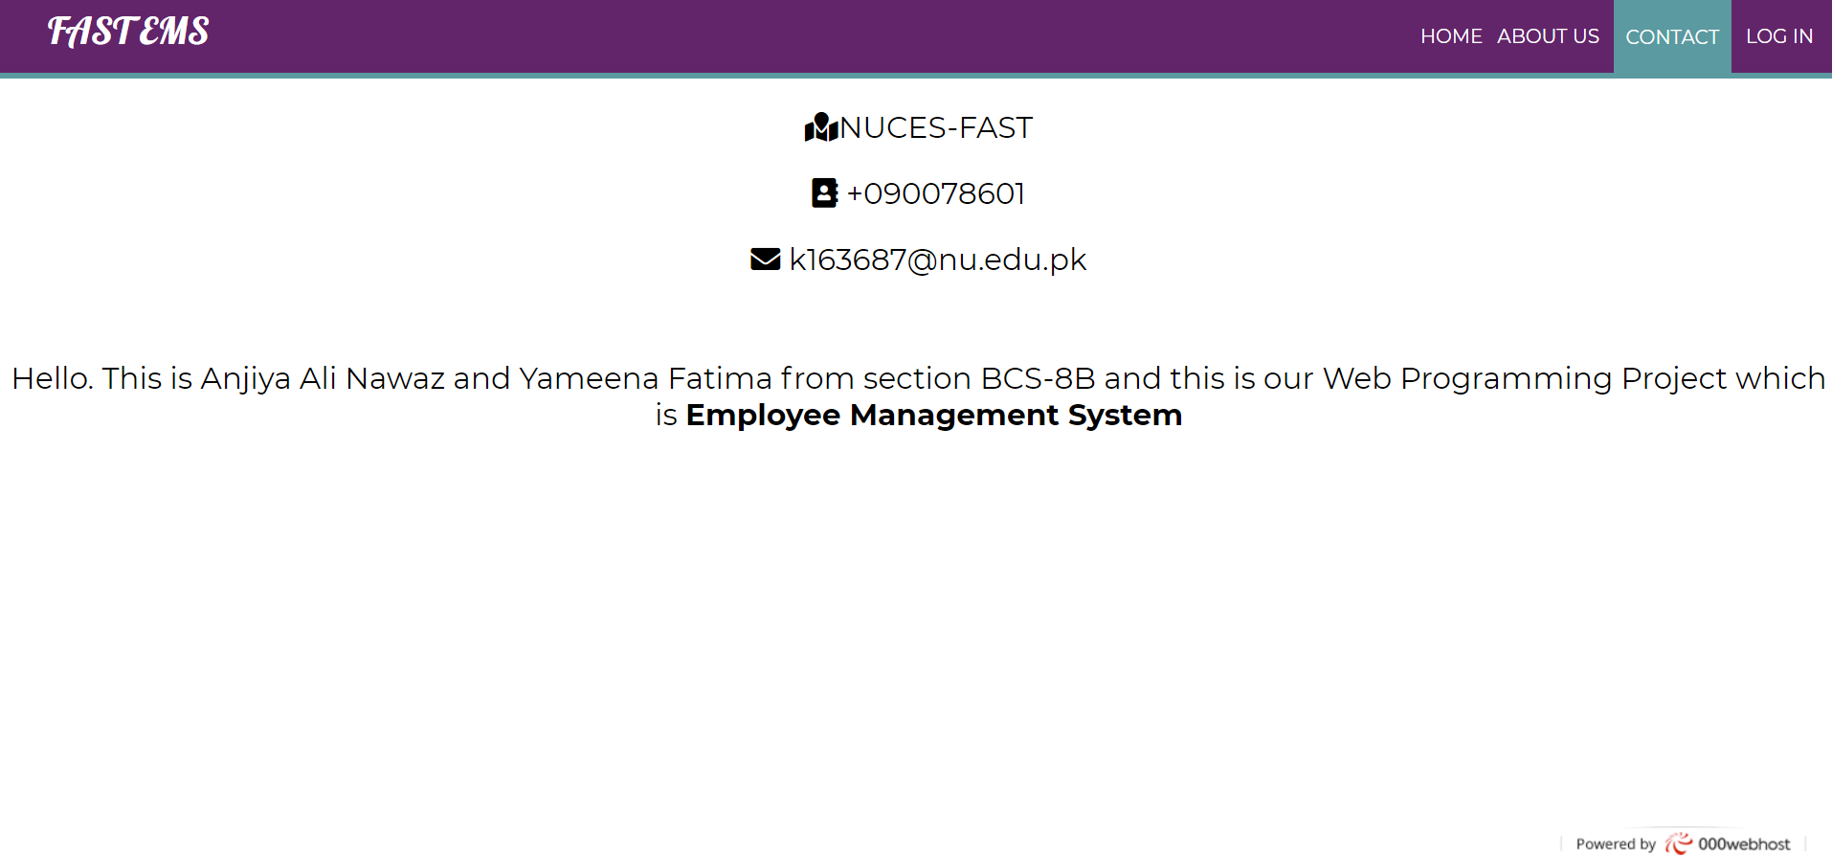

*The* ***“Contact****” Page shows information with symbols so we can be easily reached.*

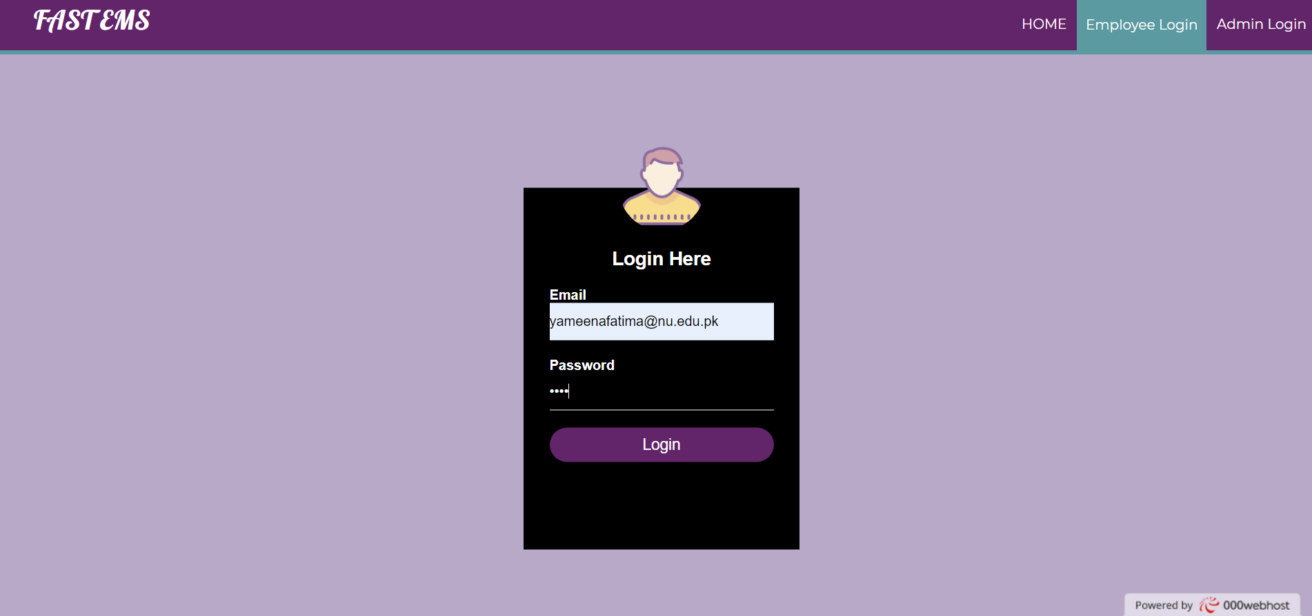

*When the user clicks on* ***“Log in”****, they are navigated to the Employee and Admin Login screens panel. This panel shows the* ***“Employee Login Screen”*** *which requires a username and password. The admin registers an employee from his account. Then when employee logs in, the data is fetched from the SQL database.*

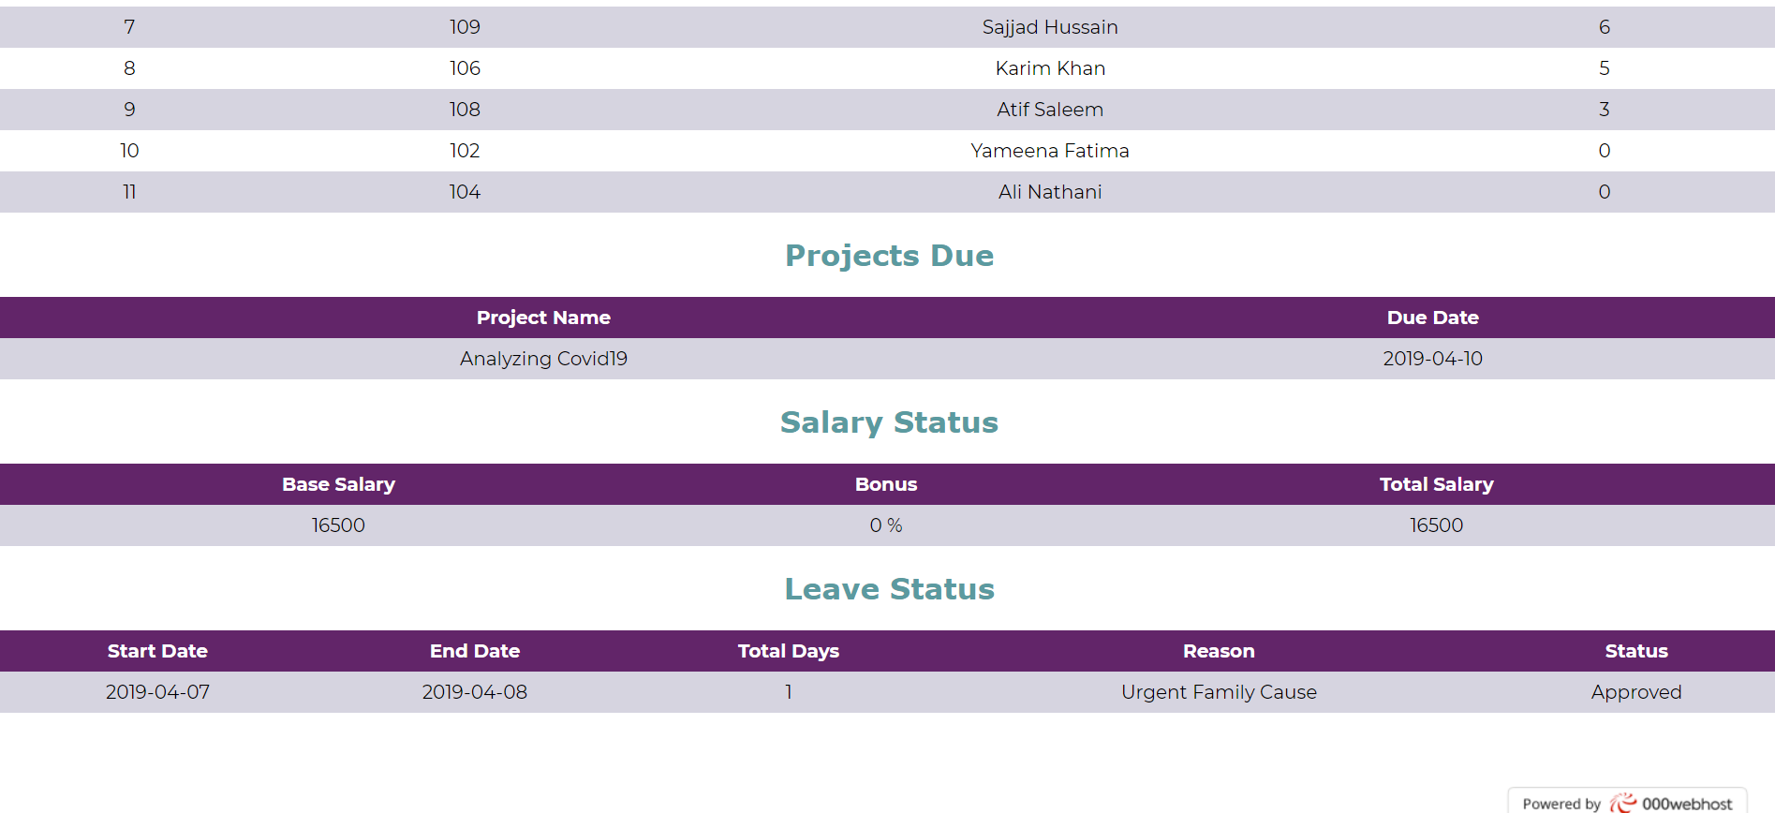

*After logging in, the employee’s* ***“Home”*** *screen shows important information, such as the leaderboard, projects due, salary and leave status. All this information has been fetched from the database after being entered by the admin.*

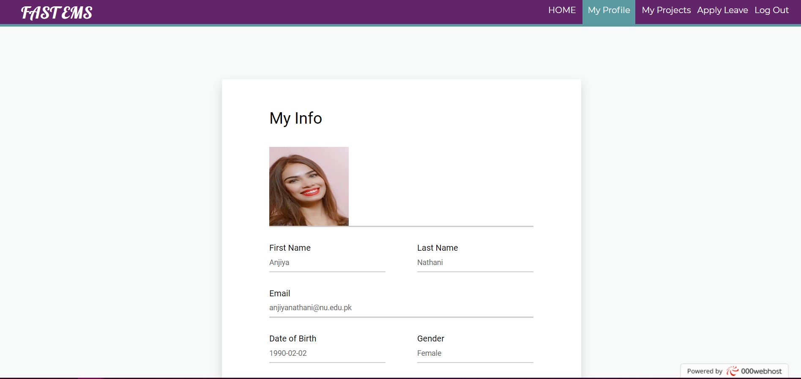

*The* ***“My Profile”*** *Page can be visited for viewing and editing personal information. The information is promptly updated in the employee SQL database, as well as with the admin.*

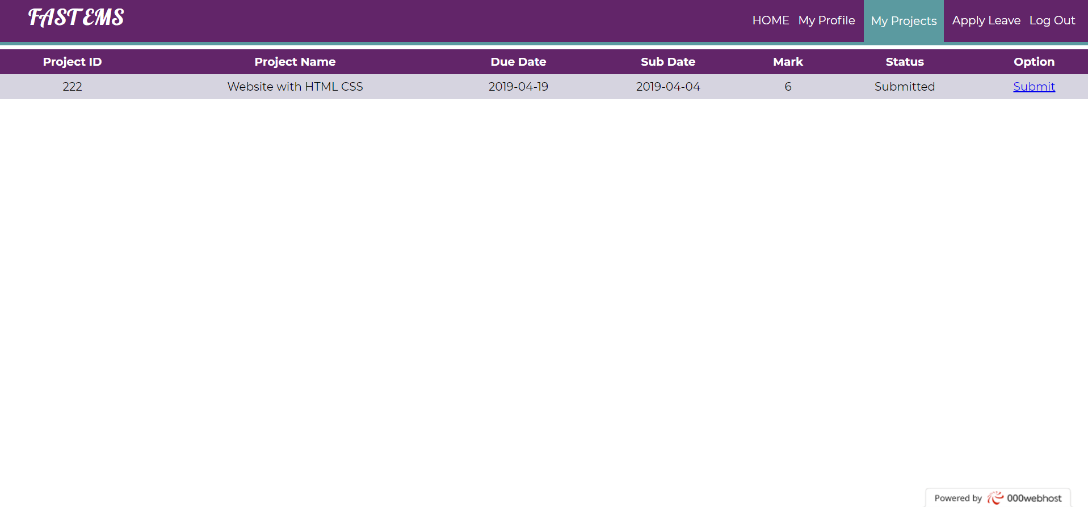

*The* ***“My Projects”*** *page shows list of projects assigned to the employee by the admin, as well their submission status. This page is also used for submitting due projects and viewing marks.*

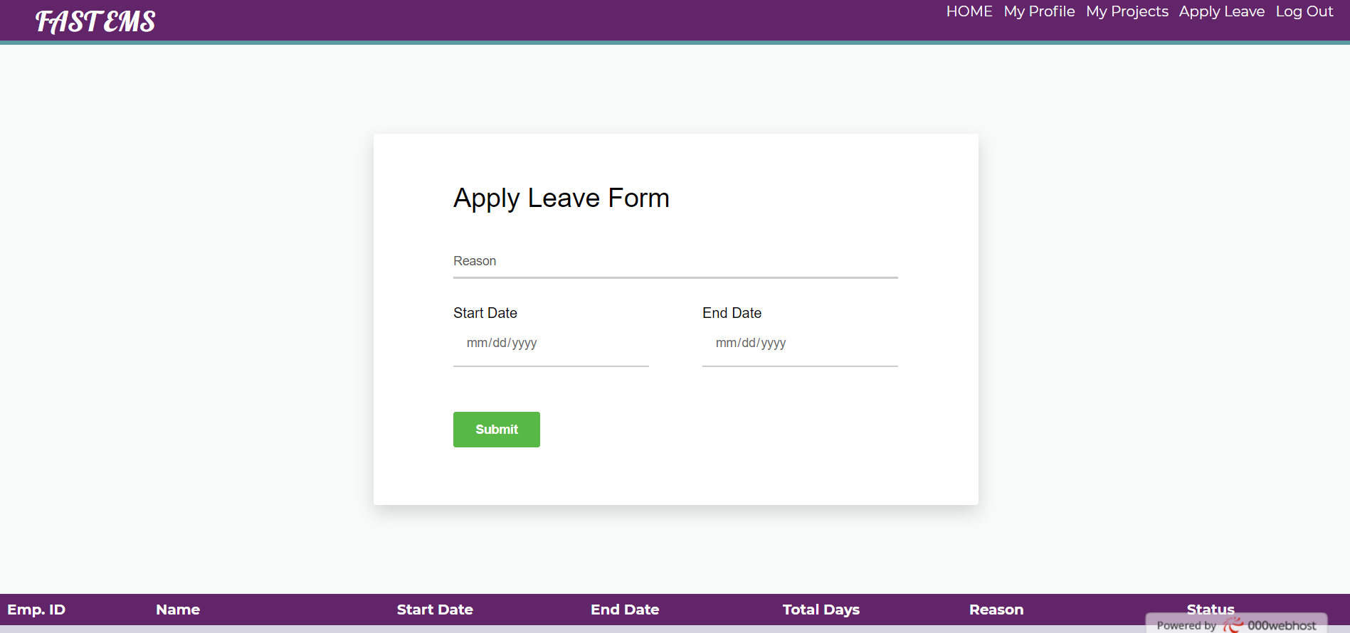

*The* ***“Apply Leave”*** *page has a form that can be filled and submitted, as a request for leave by employee to the admin. The admin will then approve or reject the request. The status of the requests can be viewed in the table below the form.*

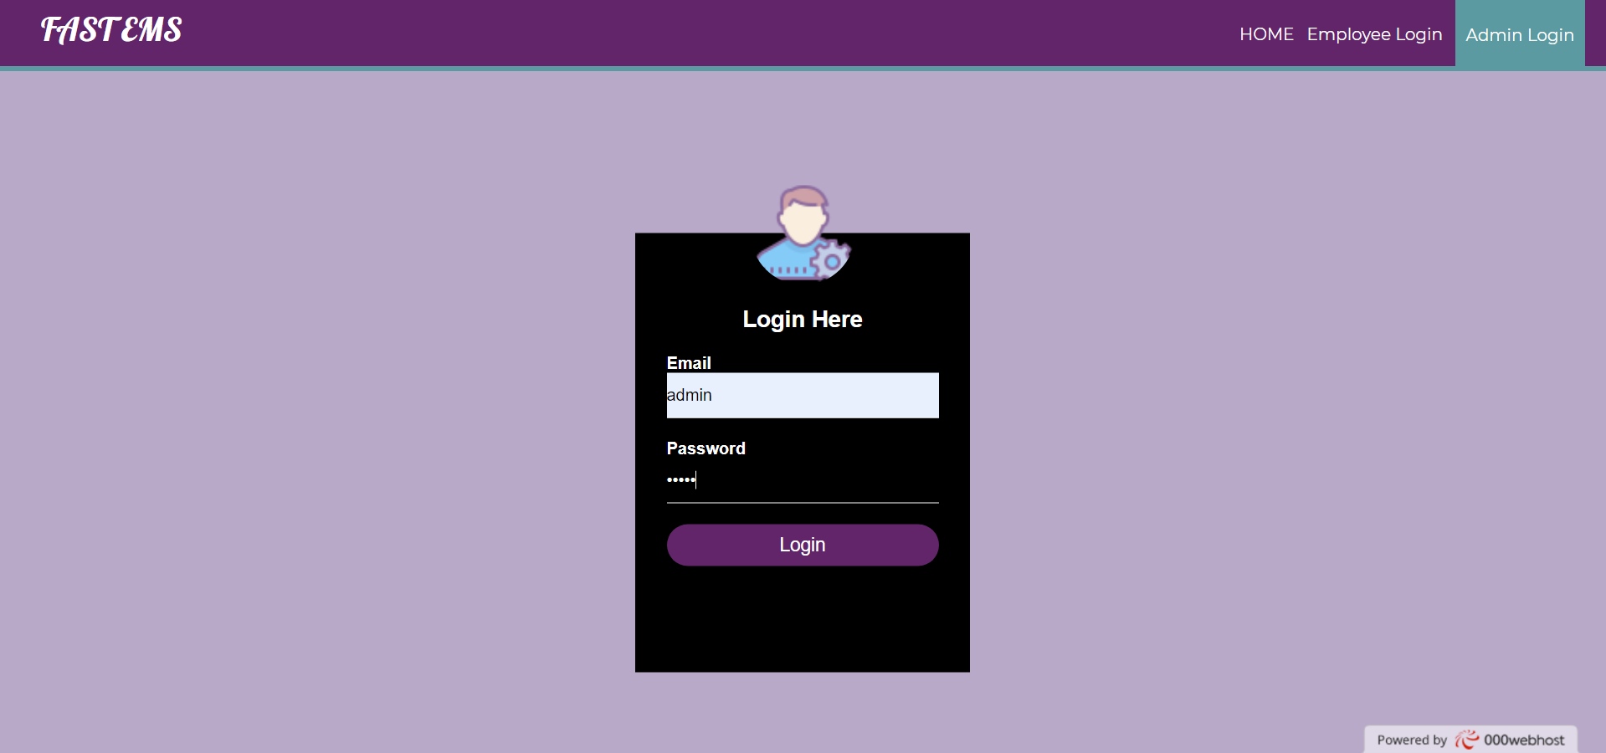

*After logging out from* ***the “Employee Login”****, we can enter the* ***“Admin Login”****. This screen shows the login page, which requires a username and password from the admin, which is pre-stored in the database.*

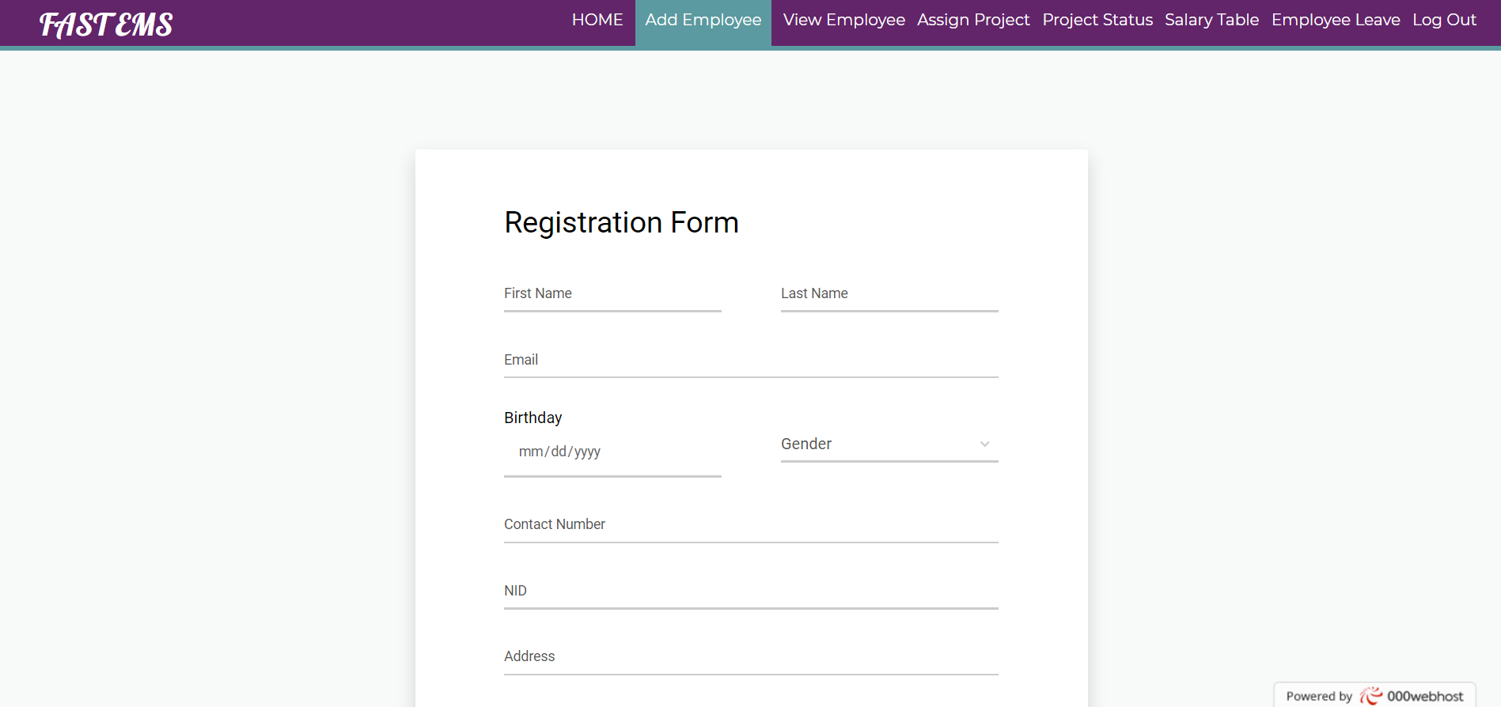

*The Admin* ***“Home”*** *screen shows the employee leaderboard. This screen is for* ***“Add Employee****” function, which has a registration form. Admin will enter new employee’s information and press submit to register employee in the database. New employees will then use provided email and password to login.*

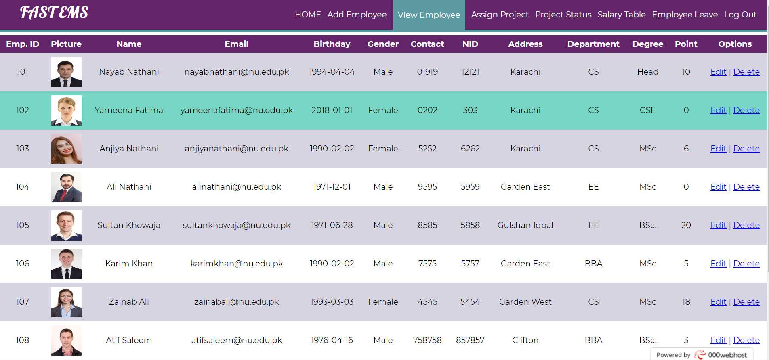

*The* ***“View Employee****” Screen shows a table of all employees in the organization, along with their basic information such as their ID, picture, Name, Email, Birthday, Gender etc...*

*The admin also has an option to* ***edit*** *their information or delete employees from the database.*

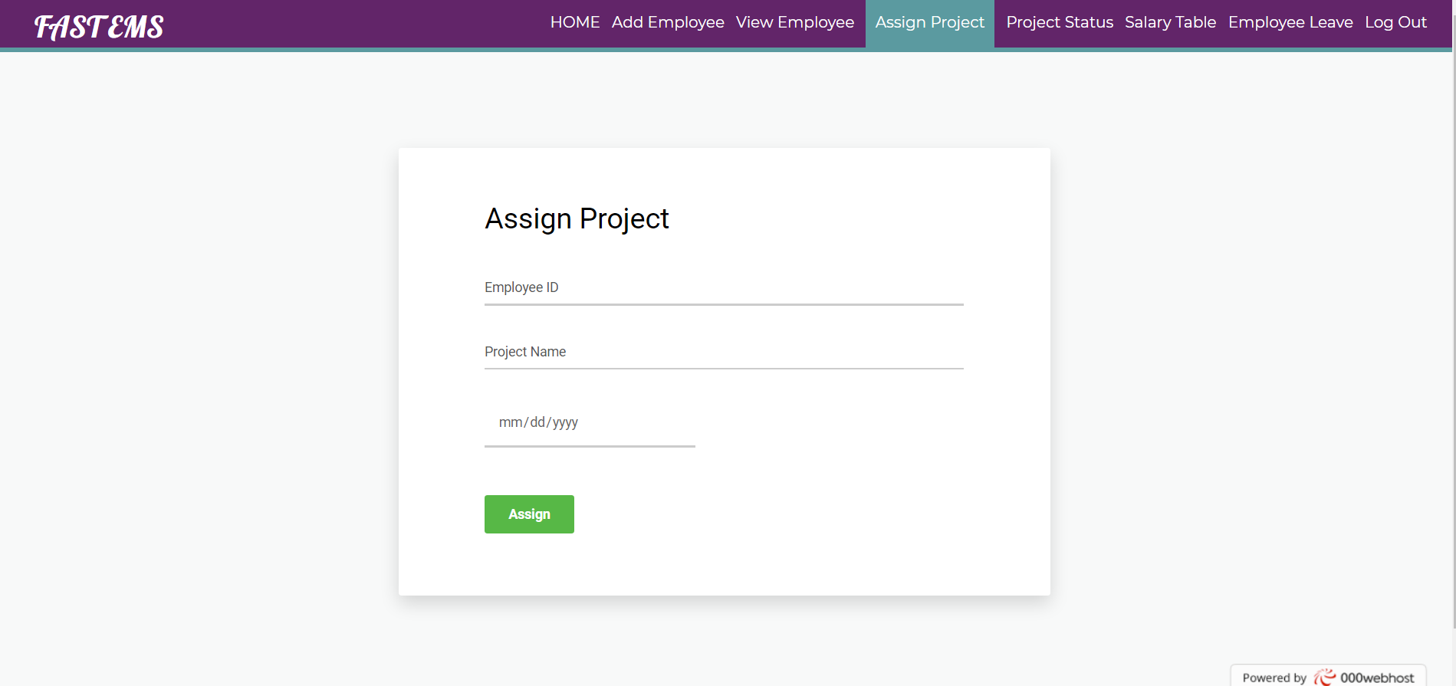

*Subsequently, the* ***“Assign Project”*** *screen has a form that can be used to assign projects to individual employees using their IDs. A due date can also be assigned to the project.*

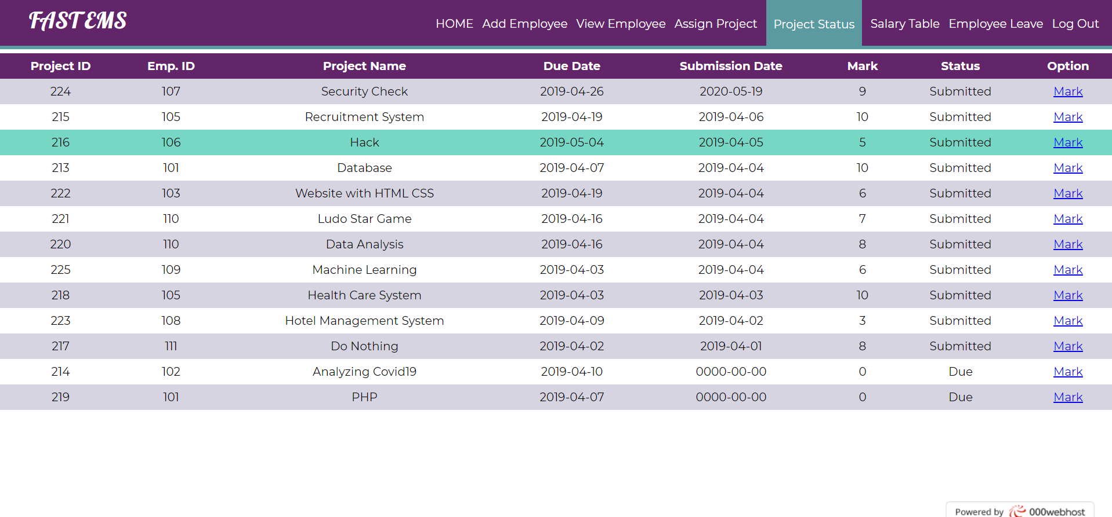

*This is* ***“Project Status”*** *Screen showing the list of all assigned projects, with employee IDs, their submission status and a marking manual. Based on the marks, a ranking is generated on the leaderboard on the* ***HOME*** *page. The top ranked employees receive a bonus.*

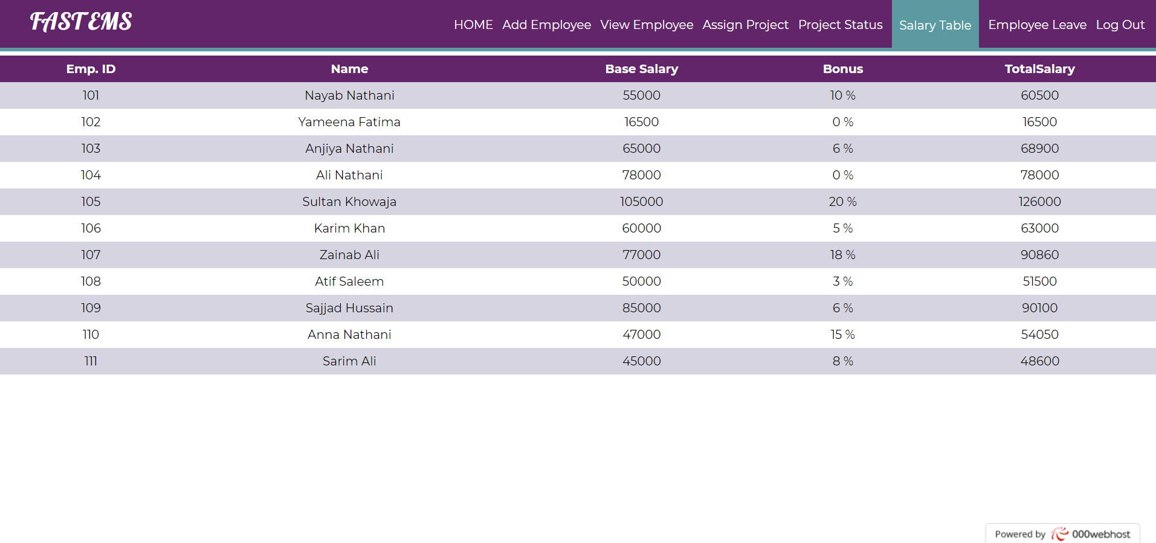

*The* ***“Salary Table”*** *shows all employees current base salary with added bonuses.*

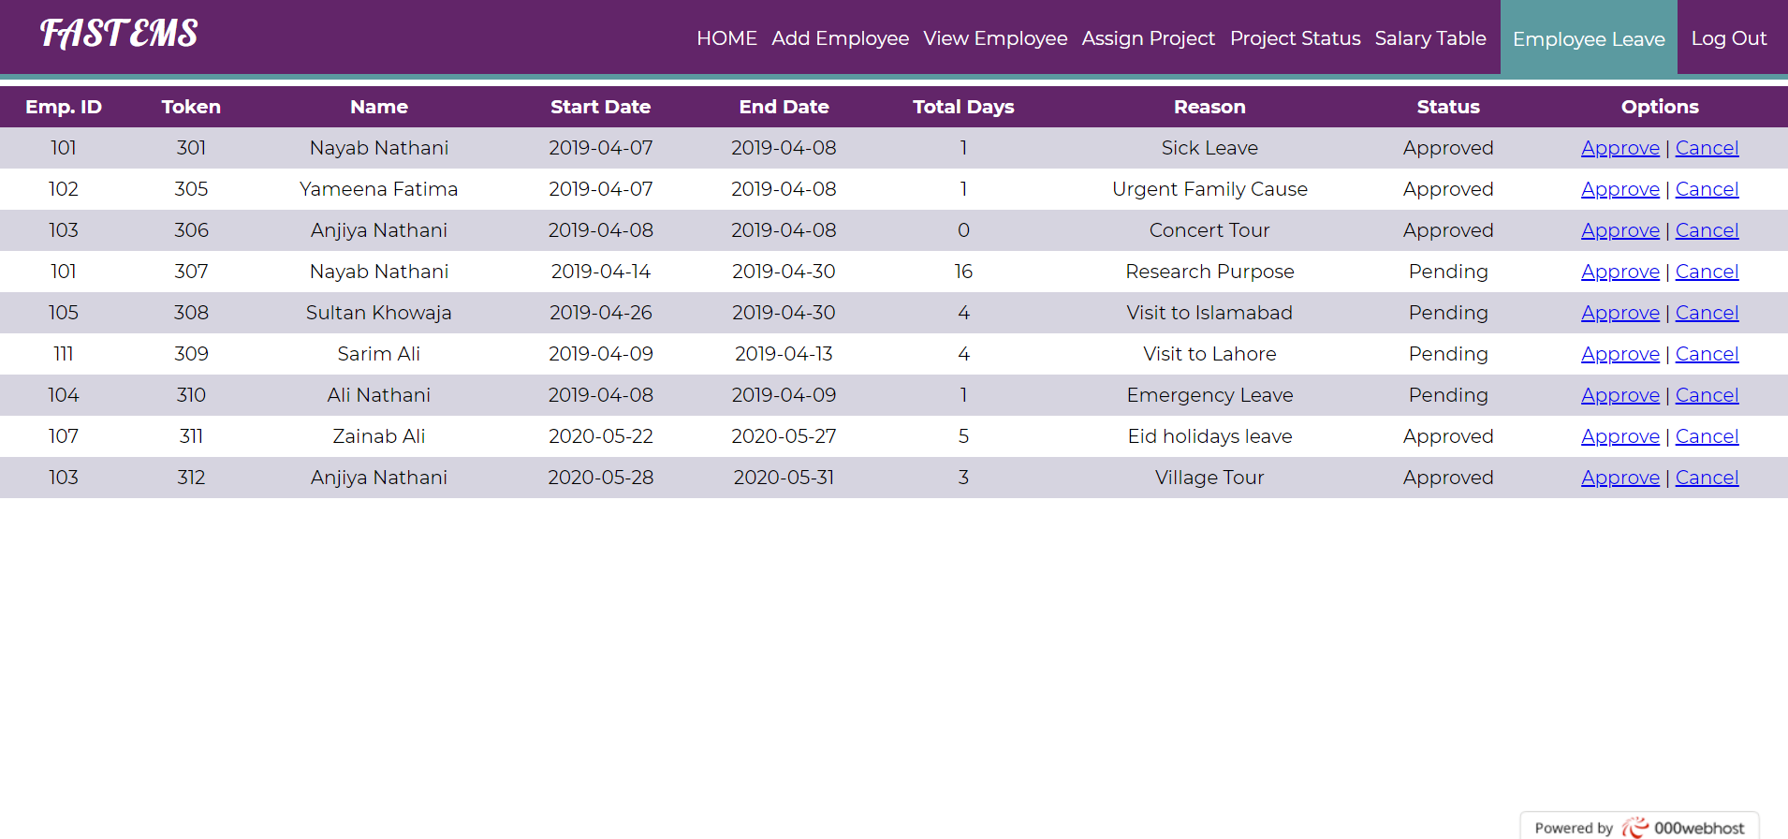

*The* ***“Employee Leave”*** *Screen shows list of employees who have applied for a leave, along with a valid reason and number of requested days off. Admin can choose to approve or reject the leave, upon which the leave status will be updated on the employee side.*

*The Admin can now* ***Log Out*** *and return to main page.*

1. **Deployment Instructions**
2. Download and extract the ZIP file called **“ems”** from CODE folder.
3. Download SQL database “370project” file from SQL folder.
4. Download and install XAMPP
5. Go to Local Disk C -> Xampp -> Htdocs folder, and paste “ems” folder.
6. Open XAMPP and start Apache and MySql servers
7. Visit <http://localhost/phpmyadmin>
8. Create new Database “370project” and import it from downloaded file
9. Visit <http://localhost/ems/>
10. You can now deploy or access the website on your own server.

For **000webhost.com** Live Hosting website, visit fast-ems.000webhostapp.com

**Host Name:** files.000webhost.com

**Port:** 21

**Username:** fast-ems

**Password:** xxxxxxxxx